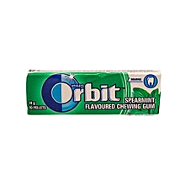
GOOD DESIGN
- Its eye catching;has a combination of good colours
- Its well detailed
- Has pictures of its ingredient (mint plants)
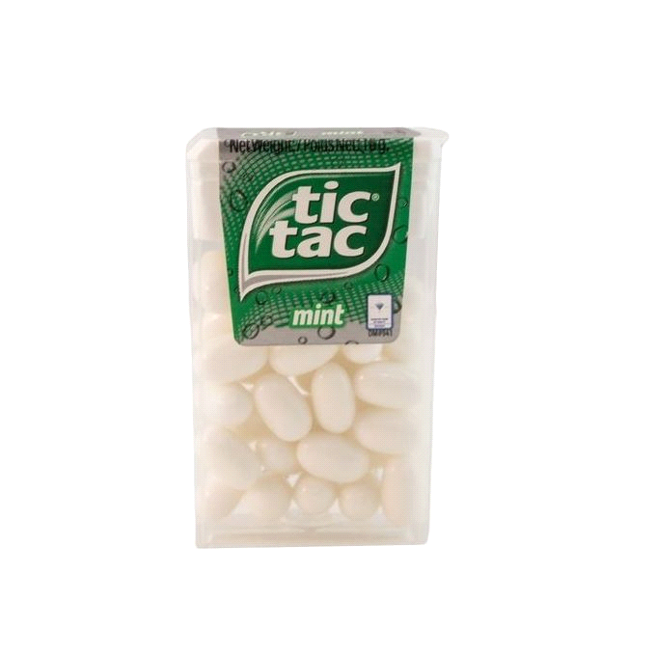
BAD DESIGN
- Its dull(not appealing to the eye)
- Has only one obvious detail i.e mint...which is the main content and we know
- Has zero pictures of what it contains

